Distributed Computing Project Proposal

Name: ________________

Project selected: ATM System.

I intend to create the ATM system described in Part B of the appendix. The system will be designed to be expandable and support arbitrary numbers of ATMs, Accounts and Banks. The ATMs will be connected to only a certain bank, and each bank will be connected to every other bank. The ATM will work as an interface, and the account calculations and updates will be completed on the machine that is the bank. The system will distribute each ATM, and each bank on to a separate machine. Banks will keep a record of each others IP addresses, however ATMs will only have a record of their bank’s IP. Figure 1 shows a proposed example of a 4 bank system, with 6 ATMs, the purple lines indicate the connections between each machine.

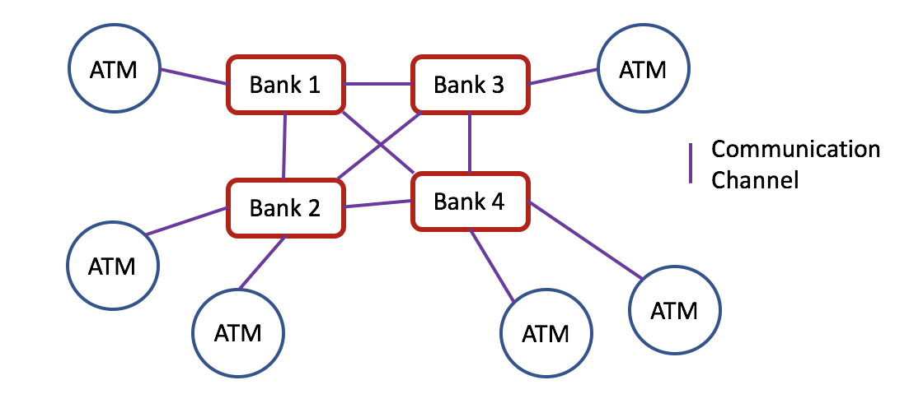

Figure . drawing of the ATM system, involving 10 machines. (6 ATM instances and 4 banks).

To complete this project, I will use Java and implement web sockets. Asynchronous message passing will be used to prevent blocking. A Java Jpanel will be used to provide a simple graphical interface for the ATM. Users will have accounts corresponding to one bank. If a user uses the ATM from a bank where their account is not stored, they will be charged a fee, but can still make their transaction as the bank will relay the transaction to the bank that the account originates from. A database of accounts/balances owned by the bank will be held only at the 1 bank that owns the accounts.

The ATM will support: deposits, withdrawals, balance checks and PIN changes. Time permitting the ATM may support other functions such as transfers between subaccounts or direct payments to other accounts.